Spatial Data Acquisition – Specific Theory
This theory section will describe the operations required to create both a raster (cell-based) and vector GIS database from various input sources. These key functions will introduce the concepts of cell sizes, resolution and scale and link these to the future modelling and analysis requirements of a GIS.

Introduction
Data input is the operation of encoding data for inclusion into a database. The creation of accurate databases is a very important part of GIS.
Data collection, and the maintenance of databases, remains the most expensive and time consuming aspect of setting up a major GIS facility. This typically costs 60-80% of the overall costs of a GIS project.
There are a number of issues which arise when developing a data base for a planning or management projects. The first issue is should the data be stored in vector or raster format. Considerations here include:
- the nature of the source data e.g. it is already in raster form
- the predominant use to which it will be put
- the potential losses that may occur in transition
- storage space (increasingly less important)
- requirements for data sharing with other systems/software
As a general rule it is best to retain the maximum amount of information in the data base. If the data is available as points, lines or polygons then it should be kept that way. If a raster approximation of this data is also needed for analytical purposes then a raster version of the data may be kept in addition to the vector coverage. Many systems provide from quick conversion from vector to raster.
The issue of scale is often raised in relation to GIS data base development. It is important to remember that data stored in a GIS does not have a scale. Sometime people refer to a 1:25000 scale data base. What they mean is that the data has been taken from 1:25000 maps or that it has a level of accuracy which is roughly equivalent to that found on 1:25000 scale maps.
In line with the principle of keeping the most information possible the ideal is to fill the data base with data with accuracies equivalent to very large scale maps. This however may not always be practical as:
- the data may not be available at very large scale,
- it may be too expensive or time consuming to digitise from that scale,
- there may be no envisioned application that requires that accuracy;
so compromises are made.
Problems can arise when some of the data in a GIS is very accurate (drawn from large scale mapping – e.g. urban utilities) and other data is drawn from much smaller scale mapping (e.g. soils). In this case great care has to be taken that conclusions are not drawn on the basis of the less reliable data.
There are several methods used for entering spatial data into a GIS, including:
- manual digitising and scanning of analogue maps
- image data input and conversion to a GIS
- direct data entry including global positioning systems (GPS)
- transfer of data from existing digital sources
- maps: scale, resolution, accuracy
At each stage of data input there should be data verification should occur to ensure that the resulting database is as error free as possible.
When developing a raster data set for specific purposes there are a number of design considerations. These include: the physical extent of the data base; the resolution (grid size); the themes to be included; the classifications to be used within the themes, and the appropriateness of scale of input data to the preferred grid size.
Physical Extent
Should the data base cover only the area being planned or managed? OR Are there external influences (upstream catchment, major transport corridors, nearby population centres, views to adjacent scenery) which need to be incorporated as part of the planning data.
Resolution
The higher the resolution the better the approximation of reality - provided the data is good enough to support this resolution. If you assume a certain error in map preparation and digitisation then this translates to a certain on ground error. There is little point in making the grid size smaller than the probable error. A smaller than necessary grid size leads to larger files and longer processing times. In the best case halving the cell size will quadruple the processing time. Experience with raster processing suggests that more than 2 million cells is excessive in most contexts. "The size of the pixel must be half of the smallest distance to be represented" Star and Estes (1990)
Themes
A lot of time and money can be wasted by seeking to build a data base which incorporates all known information about an area. It is first appropriate to determine what questions will the GIS be required to answer and what data is needed to answer those questions. For example, while geological maps of an area may be available they may be of no relevance to the specific decision process.
Classifications
What numbers are to be attached to the grid cells and what will these numbers mean. They may refer to data which is: Nominal/ Categorical, Ordinal, Interval or Ratio.
It is important to know that the range of analytical or modelling operations which are available may be limited by the type of data measure (scale) being used.

Manual digitising and scanning of analogue maps
The input of data from analogue maps required the conversion of the features into coordinate values.

digitising
Digitising is the transformation of information from analog format, such as a paper map, to digital format, so that it can be stored and displayed with a computer . Digitising can be manual, semi-automated (automatically recorded while manually following a line), or fully automated (line following).
Manual digitising involves an operator using a digitising table (or tablet) (known as heads-down digitising), or with the operator using a computer screen (heads-up digitising). The digitising table has a fine grid of wires embedded in it that acts as a Cartesian coordinate system. The coordinate may be in plane or geographic coordinates. The procedure involves tracing map features in the form of points, lines or polygons with a mouse (puck) which relays the coordinate of each sample point to be stored in the computer. The tablet and puck acting together with the computer can locate the puck s position relative to reference information provided by the operator (McGowan, 1998). There are two modes of digitising: point-mode and stream-mode (see Figures 1 and 2). The resolution of coordinate data is dependent on mode of digitizing:
In point-mode the digitizing operator specifically selects and encodes those points deemed "critical" to represent the geomorphology of the line or significant coordinate pairs. This requires some knowledge about the line representation that will be needed.
In stream-mode the digitizing device automatically selects points on a distance or time parameter, which generates sometimes an unnecessary high density of coordinate pairs.
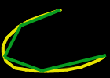
Figure 1 Point-mode digitising
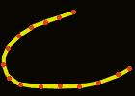
Figure 2 Stream-mode digitising
On-screen digitising is an interactive process in which a map is created using previously digitised of scanned information. This method of geocoding is commonly called "heads-up" digitising because the attention of the user is focused up on the screen, and not on a digitising tablet. This technique may be used to trace features from a scanned map or image to create new layers or themes. On-screen digitising may also be employed in an editing session where there is enough information on the screen to accurately add new features without a reference image or map.
The process of on-screen digitising is similar to conventional digitising. Rather than using a digitiser and a cursor, the user creates the map layer up on the screen with the mouse and typically with referenced information as a background.
There is always a requirement to transform coordinates from the digitiser system to the real world system (e.g. national map grid).
Digitising errors will always occur (undershoots, overshoots, triangles).
Editing of digitised features involves error correction, entering missing data, forming topology.
There are many issues to consider before digitising commences, including (McGowan, 1998):
- For what purpose will the data be used?
- What coordinate system will be used for the project
- What is the accuracy of the layers to be associated? If it is significantly different, the layers may not match.
- What is the accuracy of the map being used?
- Each time you digitise, digitise as much as possible. This will make your technique more consistent. For more consistency, only one person should work on a given digitising project.
- If the source consists of multiple maps, select common reference points that coincide on all connecting sheets. Failure to do this could result in digitised data from different data sheets not matching.
- If possible, include attributes while digitising, as this will save time later.
- Will it be merged with a larger database?

Map registration or Georeferencing
Registration of the map needs to be performed for each new digitizing session, as well as each time the map’s position is changed on the digitizer (see Figure 3).
This is so that the coordinates of the digitiser can be converted into geographic coordinates. The digitising program will require the map scale, and the geographic coordinates of the control points which will be used. These control points should generally be well spaced, for example near the corners of the map. Depending on the software being used a minimum of four points are required. These locations of these points then need to be digitised.
Always use the same control points for each session of a particular map sheet.
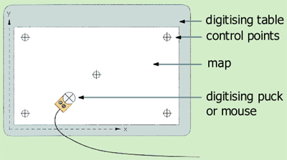
Figure 3 The digitiser table and puck
Some software may require the establishment of the size of the digitizing window by clicking in the lower left corner and upper left corner of the region of interest.
An error limit needs to be specified. This is the maximum error that is acceptable to register your paper map. The default error limit is 0.004 inches (or its equivalent units). Once you enter a minimum of 4 pairs of map and paper control points, ArcView calculates the Root Mean Square (RMS) error and compares the value with the one you specified in the Error Limit edit box. If the calculated error is less than the specified error limit, Register button is enabled for you to register the map.

RMS error
The Root Mean Square (RMS) error represents the difference between the original control points and the new control point locations calculated by the transformation process. The transformation scale indicates how much the map being digitised will be scaled to match the real-world coordinates.
The RMS error is given in both page units and in map units. To maintain highly accurate geographic data, the RMS error should be kept under 0.004 inches (or its equivalent measurement in the coordinate system being used). For less accurate data, the value can be as high as 0.008 inches or its equivalent measure.
Common causes of high RMS error are - incorrectly digitised control points, careless placement of control points on the map sheet, and digitising from a wrinkled map. For more accurate results when digitising a control point, check that the crosshairs of the digitiser puck remain centered on the control point.

Scanning
Another approach is to use a scanner to convert the analogue map into a computer-readable form automatically. One method of scanning is to record data in narrow strips across the data surface, resulting in a raster format. Other scanners can scan lines by following them directly.
Maps are often scanned in order to:
- Use digital image data as a background for other (vector) map data
- Convert scanned data to vector data for use in a vector GIS
Scanning requires that the map scanned be of high cartographic quality, with clearly defined lines, text and symbols; be clean and have lines of 0.1mm width or wider.
Scanning comprises two operations:
- scanning, which produces a regular grid of pixels with grey-scale levels (usually in the range 0-255)
- binary encoding – to separate the lines from the background using automated feature recognition techniques
Editing of scanned data can include: pattern recognition of shapes and symbol candidates; line thinning and vectorisation; error correction; supplementing missing data, and forming topology.
See Berhardsen (1992) for more detail.

Direct data entry

Surveying and manual coordinate entry
- In surveying, measured angles and distances from known points are used to determine the position of other points
- Surveying field data are almost always recorded as polar coordinates and transformed into rectangular coordinates

Surveying field data are almost always recorded as polar coordinates and transformed into rectangular coordinates. Polar coordinates are composed of: a measured distance and an angle measured clockwise from North.

Global positioning systems (GPS)
A Global Positioning System (GPS) is a set of hardware and software designed to determine accurate locations on the earth using signals received from selected satellites. Location data and associated attribute data can be transferred to mapping and Geographical Information Systems (GIS). GPS will collect individual points, lines and areas in any combination necessary for a mapping or GIS project. More importantly, with GPS you can create complex data dictionaries to accurately and efficiently collect attribute data. This makes GPS is a very effective tool for simultaneously collecting spatial and attribute data for use with GIS. GPS is also an effective tool for collecting control points for use in registering base maps when known points are not available.
GPS operate by measuring the distances from multiple satellites orbiting the Earth to compute the x, y and z coordinates of the location of a GPS receiver.
The following forms of GPS equipment are currently available to users:
- Small hand-held units
- 'James Bond'-type wristwatch units
- In-car navigation systems
- Back-pack units
- Aircraft and ship mounted systems
- Belt-mounted units which can be linked directly to wearable computers containing GIS databases
- Mobile telephone installed units

Uses of GPS
GPS can be used for georeferencing, positioning, navigation, and for time and frequency control. GPS is increasingly used as an input for Geographic Information Systems particularly for precise positioning of geospatial data and the collection of data in the field.

The system
The system hardware contains three parts; the antenna, the receiver, and the datalogger; sometimes called a data-collector.
The datalogger is a hand-held computer that contains software to coordinate signal collection and storage, file manipulation, and file transfer to and from a computer. Some systems might combine some of these elements into a single piece of hardware.
The system software, which normally resides on a computer, has four primary functions: preplanning, post-processing correction of the raw satellite data, display/editing of the data, and converting/exporting of the data. Preplanning includes determining satellite availability for a particular place and time, and the preparation of data dictionaries for a particular job. Correction involves the use of a base station file to apply corrections to the raw data collected from the satellites, greatly improving accuracy.
Editing and display can include averaging points, connecting points to form lines or areas, smoothing, measuring distance and area, and displaying the data to screen. GPS software programs are not meant to be map-making programs and usually most of the final editing will take place in a GIS program.
Data conversion and export include the capability to convert from the spherical Latitude/Longitude (Lat/Long) coordinates that the receiver collects into a variety of other coordinate systems and datums, and then exporting this data in a variety of formats used by different CADD and GIS programs.

The satellites
The known distances and locations of each visible satellite are used to locate the position of the receiver. We can place ourselves anywhere on a sphere around one satellite once we know the distance to the satellite. Known distances from two satellites will place us on a circle that is the intersection of two spheres. Known distances from three satellites will place us in two points, which is the intersection of three spheres. We may be able to eliminate one of these points as being impractical, such as out in space or deep underground. With one gone, the other must be correct. Three satellites are sufficient, at least theoretically, to provide receiver location. More satellites simply add confirmation to the receiver location. In practice, the more satellites the better. Four satellites are the minimum to secure only one, absolutely technically, trigonometrically unambiguous location. Three work in practice since we can eliminate the absurd location.
Four satellites (normal navigation) can be used to determine three position dimensions and time. However user mistakes, including incorrect geodetic datum selection, can cause errors from 1 to hundreds of meters. Receiver errors from software or hardware failures can also cause errors of any size.
GPS satellite signals are blocked by most materials. GPS signals will not mass through buildings, metal, mountains, or trees. Leaves and jungle canopy can attenuate GPS signals so that they become unusable. In locations where at least four satellite signals with good geometry cannot be tracked with sufficient accuracy, GPS is unusable. Planning software may indicate that a location will have good satellite coverage over a particular period, but terrain, building, or other obstructions may prevent tracking of the required satellites.
The GPS satellites circle the earth twice a day, 10,900 miles above the earth. There are 24 satellites in the GPS constellation. Twenty-one satellites can be called on at any time; the other three are spares in case one of the others becomes unhealthy.
Five or six satellites are above and visible (by radio wave) to any spot on the earth at any one time. Buildings, hills, trees, and other ground features may block one or more at one time, or one or two of the satellites may not be at their best. These problems will reduce the number of useful satellites above a position to two, and maybe even one, but three or four are commonly available. Often as many as five and six are visible.
The location in space of each satellite is known. The orbits are carefully planned and constantly updated so that actual location is never off by much from the intended location. Each satellite constantly announces its number, and the time that signal was sent.
The distance from each satellite to the receiver is calculated by comparing the time the signal says it was sent with the time the receiver picks up the signal. The time difference is multiplied by the speed of light to get the distance from satellite to receiver. This is done for each satellite the receiver can "see".

Differential GPS (DGPS) Techniques
The idea behind all differential positioning is to correct bias errors at one location with measured bias errors at a known position. A reference receiver, or base station, computes corrections for each satellite signal for all satellites in view (see Figure 4). Differential GPS are measured at two stations, one of which has known coordinated. Correction values can then be used to calculate the exact position of the unknown points from the roving receiver. In this way it is possible to calculate the exact position of survey control stations on land or of mobile objects such as boats. The use of differential GPS helps users achieve better accuracy.
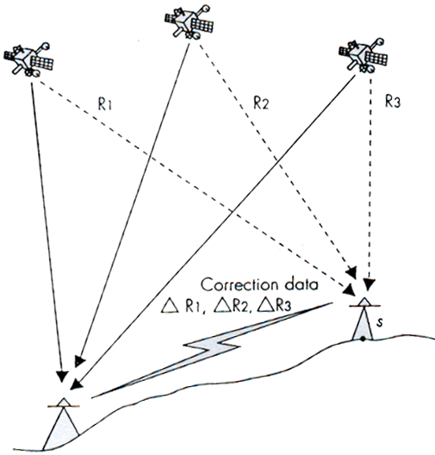
Figure 4 Differential GPS

Image data input and conversion to a GIS
Image data includes satellite images, aerial photographs and other remotely sensed or scanned data. Image data is in a raster data. Each grid-cell, or pixel, has a certain value depending on how the image was captured and what it represents. For example, if the image is a remotely sensed satellite image, each pixel represents light energy reflected from a portion of the Earth's surface.

Remote Sensing
Remote sensing includes all information collected from sensors which are physically separate from the object. In the context of this thesis, remote sensing is concerned with deriving information about the Earth's surface using an elevated platform, to produce such information as satellite data or aerial photography.
Figure 5 Part of a satellite image
Remote sensing instruments rely upon the detection of energy emitted from, or reflected by, the object under consideration. Remote sensing allows the measurement and monitoring of surface electromagnetic variation, and as such this data provides a unique way of viewing the landscape. Satellite remote sensing is the only source of data with which we can view the entire planet and monitor the change in the nature of the surface of the planet through time, in a consistent, integrated, synoptic and numerical manner.
Satellite remote sensing has the ability to provide complete, cost-effective, repetitive spatial and temporal data coverage, which means that various phenomena can be analysed synoptically, and such tasks as the assessment and monitoring of land condition can be carried out over large regions.
As well as being of use by itself, remote sensing can be also be used as an important data source for the development and refinement of models, and can be used to validate models.
When using satellite remote sensing, the relationship between spectral response and ground features is complicated by the fact that individual image cells (pixels), which can range from 10 m to 1 km in size depending on the source of data used, are heterogeneous and may contain a mixture of phenomena (see Figure 5 below). The individual spectral responses of features within a cell are averaged to produce the value for the cell. Therefore, methods of remote sensing will only be effective if the phenomena, or classes of the phenomena, cover areas larger than a pixel.
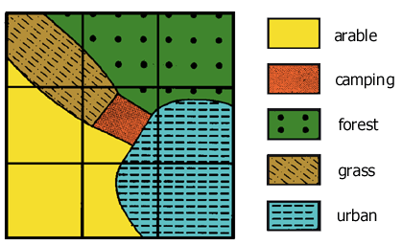
Figure 5 Classification errors occur when the size of the grid cell s larger than the features which are being mapped (after Burrough, 1986 Figure 6.3 p.112)
Therefore the spectral data needs to be enhances, filtered or perhaps geometrically transformed with image processing techniques before it can incorporated into a GIS. An important problem is the rectification of the remotely sensed imagery with the grid which the GIS is using.
Rectification is the process by which and image or grid is converted form image coordinated to real-world coordinates. Rectification typically involves rotation and scaling of grid cells and thus requires resampling of values. This is achieved by using resampling techniques which involve defining new pixel positions for the GIS map grid, and filling them with data determined by interpolation algorithms such as nearest neighbour, bilinear interpolation or cubic convolution (see the Raster Spatial Analysis Module for more information on spatial resampling).

Aerial photographs, air photo interpretation and digital photogrammetric mapping
Aerial photographic interpretation has been the most widely used form of remote sensing for environmental applications to date, with techniques being well established. This wide use stems from the availability of aerial photographs, and the fact that they can provide very high spatial resolution data, down to metre accuracy, not historically available from other sensors.
Qualitative analysis relies on image interpretation and is basically descriptive. Photo interpretation involves a human analyst viewing an image, and extracting information, and due to its use of the human mind, is unequalled in the possibilities of pattern recognition and spatial association. The success of this technique is highly dependent on the analyst effectively exploiting the spatial, spectral and temporal elements present in the image. Images, whether aerial photographs or satellite imagery, have a very high descriptive value due to the ability of the human interpreter to interpolate and find patterns.
For both aerial photographs and space-borne remotely sensed data, the scale of the image will determine to a large extent the potential of the interpretation.
Photo interpretation, whether of aerial photography or of satellite remote sensing data, is prone to the problems of being non-repeatable and not offering uniformity of analysis. It is highly subjective and depends upon the interpreter’s knowledge and understanding of the spatial area under consideration and the process or phenomena involved.
- The combination of aerial photography and air photo interpretation provides information on relatively large areas without inspection of the ground
- Roads, lakes and water bodies, building, farmland and forests are clearly visible on aerial photographs
- Other characteristics such as vegetation, soil and geological formations are more difficult to interpret, however skilled and experienced interpreters can extract a great amount of useful information from aerial photography
- Using air photo interpretation, the aerial photograph is classified by the interpreter, with the data being then input into a database or is used for the updating of previously held information
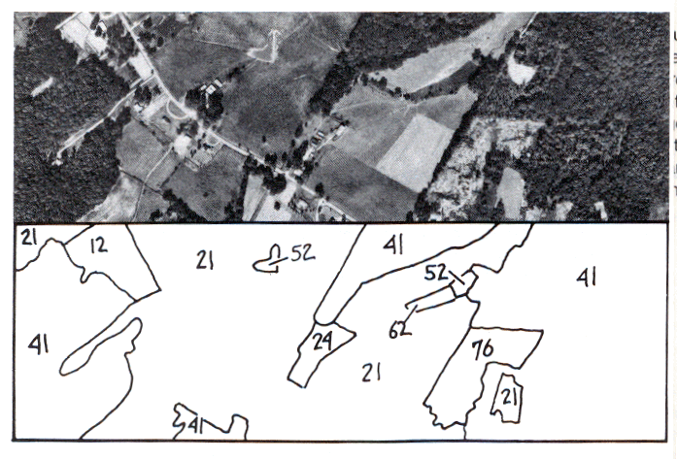Figure 6 Aerial Photo Interpretation of an image into classes (Campbell, 1983)
Digital photogrammetric mapping uses digital images of a pair of overlapping photographs and operators use special 3D glasses to digitise (x, y, z) coordinates of features.
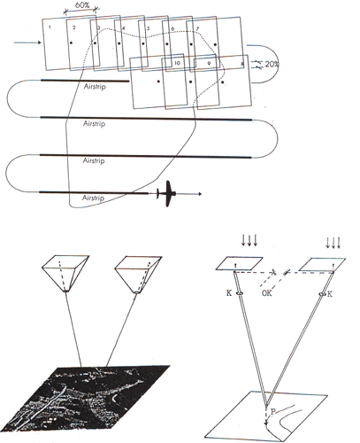
Figure 7 Flight path for aerial photography shown above, where the whole area is covered by aerial photographs usually with a 60% overlap along each flight line and a 20% overlap between flight lines. The lower part of the image shows the idea behind the use of a pair of stereo images for stereo-plotting or image interpretation.

Transfer data from existing digital sources
A change is occurring in the transformation data into a GIS database. Originally most of the data was derived from digitising analogue maps, or from direct data entry. Now a large amount of information is now distributed in digital formats, so there is a wider use of existing digital sources.
The digital data ‘revolution’ also means that users must often search for materials in different places. To acquire some digital sources, users must contact the producers directly to gain the necessary data in a compatible format. Such data can be obtained from Government Agencies such as Australian Geological Survey Organisation http://www.agso.gov.au , the Australian Survey and Land Information Group (AUSLIG) http://www.auslig.gov.au , and other sources.
The Internet and Worldwide Web are being used to distribute data to a greater extent by many organizations and agencies. The US Federal Geographic Data Committee's web page at http://www.fgdc.gov has the US National Geospatial Data Clearinghouse containing links to hundreds of organisations that maintain and provide GIS data, both in the US and around the world. In some cases, you can download the data directly and use it in ArcView.
ESRI's web page (http://www.esri.com) also contains links to organizations that maintain and provide GIS data. From the web page you can check out the Data Hound: it's a good place to start your quest for data. The Data Hound offers links to other GIS sites that offer free, downloadable data.
The real problem at the local and state levels is that government agencies organize themselves--and their data--in very different ways from place to place. Because states and cities vary so greatly in their systems of organization, it sometimes takes time to discover which agency holds the information you want. In some cases, states and cities are required to collect certain types of information to comply with federal and state regulations—but again the agencies that actually compile this information may vary from place to place.
The issue then becomes one of transferring the data from the supplied format into that needed.
When GIS first began to appear, users either developed their own formats for storing spatial information or employed those defined by data holders and their software.
The formats were often specific to the needs of particular projects and were not intended to meet the needs of a broader range of users. It was often very difficult to share and transfer data. Users recognized that much time and money was being wasted when datasets could not be shared among a broader clientele.
The United States Geological Survey (USGS) was one of the first agencies to begin experimenting with data formats that could serve both their needs and those of a wider public. The USGS's digital line graphs (DLG) was the result, although both of these early formats have since been further refined into the DLG-2 format. The DLGs were a way of coding information drawn from the USGS's conventional paper quadrangle sheet maps.
The development of standards and the proliferation of conversion and translation software has had a galvanizing effect on the GIS world. Where once users had to count on digitizing datasets from scratch, they can now use a wide range of publicly available files. The growth in available files has been huge. The emergence of new data transfer standards may increase the pace of development further.
Common data transfer formats include:
- Australian Spatial Data Transfer Standard (SDTS)
- DXF (Drawing Exchange File)
- JPEG files
- VPF (Vector Product Format data
Most GIS packages now contain a suite of software algorithms that will perform the necessary data transfers.
The data obtained from other sources should contain meta-data, that is data about the data, or a sort of "data quality report" from the provider. This data will provide a description of exactly what is in the file, how the information was compiled (and from what sources), and how the data was checked. The documentation for some products is quite extensive and much of the detailed information may be published separately, as it is for USGS digital products.
If documentation is limited, it is important for you to consider the following questions:
- What is the age of the data?
- Where did it come from?
- In what medium was it originally produced?
- What is the areal coverage of the data?
- To what map scale was the data digitized?
- What projection, coordinate system, and datum were used in maps?
- What was the density of observations used for its compilation?
- How accurate are positional and attribute features?
- Does the data seem logical and consistent?
- Is the data relevant to the project at hand?
- In what format is the data kept?
- How was the data checked?
- Why was the data compiled?
- What is the reliability of the provider?

Maps

map scale
Map scale is the relationship existence between distance on a map and the corresponding distance on the earth. It is usually expressed in the following form: 1:10,000, meaning that 1 unit of measurement on the map represents 10,000 of the same units on the earth’s surface. The scale ratio 1:100,000 means that one unit of distance on the map represents 100,000 of the same units of distance on the Earth. So on a 1:100,000 scale map, one cm on the map equals one km on the ground because one km has 100,000 cm. Because the scale ratio is a constant, it is true for whatever units in which the fraction is expressed.
A ‘large’ scale map is one in which a given part of the Earth is represented by a large area on the map. Large scale maps generally show more detail than small scale maps because at a large scale there is more space on the map in which to show features. Large scale maps are typically used to show site plans, local areas, neighborhoods, towns etc. 1:2,500 is an example of a large scale.
A ‘small’ scale map is one in which a given part of the Earth is represented by a small area on the map. Small scale maps generally show less detail than large scale maps, but cover large parts of the Earth. Maps with regional, national, and international extents typically have small scales, such as 1:1,000,000. Large scale maps typically show more detail than small scale maps, whereas on smaller scale maps there is simply not enough room to show all the available detail, so features such as streams and roads often have to be represented as single lines, and area features like cities, have to be shown as points. This is called generalization.
The larger a scale is the smaller will be the number in the scale. For example, a 1:10,000-scale map is said to have a larger scale than a 1:100,000-scale map.

Map projections
Map projections are a mathematical model for converting locations on the earth’s surface from spherical to planar coordinates, allowing flat maps to depict three-dimensional features. Some map projections preserve the integrity of shape, others preserve accuracy of area, distance or direction. All map projections distort shape, area, distance or direction to some extent.
On large scale maps, such as street maps, the distortion caused by the map projection being used may be negligible because your map will typically cover only a small part of the Earth's surface.
On smaller scale maps, such as regional and world maps, where a small distance on the map may represent a considerable distance on the Earth, this distortion may have a bigger impact, especially if the application involves comparison of the shape, area or distance of different features. In these cases, knowledge of the characteristics of the map projection you are using becomes more important.

Map detail
It is natural to equate detail with accuracy. However, when we talk about the level of detail on a map, we are referring to the quantity of geographic information shown. Map accuracy, on the other hand, is a statement of the quality of this information.
While large scale maps typically show more detail than small scale maps, there is no standard rule for how many features a map of a given scale can show, and in how much detail. Instead, this is a cartographic decision depending on the purpose of the map and how many symbols can be drawn in the available space without visual clutter.
On smaller scale maps there is simply not enough room to show all the available detail, so features such as streams and roads often have to be represented as single lines, and area features like cities, have to be shown as points. This is called generalisation.
When features are generalised their level of detail is reduced to avoid cluttering the map, but their overall shape and position is retained. Therefore, a small scale map of a coastline will not show every cove that you might see on a large scale map. Smaller scale maps may also omit features completely.
In some GIS packages spatial data can be generalized after it has been created. ARC/INFO has functions for automatically generalizing existing spatial data by removing coordinates.

Map accuracy
The accuracy of a map is not dependent on the map's scale. Instead, it depends on the accuracy of the original data used to compile the map, how accurately this source data has been transferred onto the map, and the resolution at which the map is printed or displayed.
The accuracy of the maps you create with ArcView depends primarily on the quality of the coordinate data in your spatial database. To create the spatial data, existing maps or manuscripts may have been digitized or scanned, and other original data, such as survey reports, aerial photographs and images, and data from third parties may also have been used. Your final map will therefore reflect the accuracy of these original sources.
As scales become smaller, one unit of map distance represents a larger distance on the ground. So if one of the features shown on a very small scale map is out of line by just a part of a millimeter, it would still represent a substantial inaccuracy in reality.

Map resolution
Map resolution is defined as:
- the size of the smallest feature that can be represented in a surface.
- the accuracy at which the location and shape of map features can be depicted for a given map scale. In a large scale map (e.g. a map scale of 1:1) there is less reduction of features than those shown on a small scale map (e.g. 1:1,000,000). On a larger scale map feature resolution more closely resembles real-world features. As map scale decreases, resolution also diminishes as feature boundaries must be smoothed, simplified or not shown at all (Berry, 1995).

References
Bernhardsen, T. (1992) Geographic Information Systems. Viak IT/Norwegian Mapping Authority, Arendal, Norway.
Benrhardsen, T. (1996) Geographic Information Systems. Halsted Press.
Bernhardsen, T. (1999) Geographic information systems : an introduction. Wiley, New York.
Berry, J.K. (1995) Beyond Mapping: Concepts, Algorithms and Issues in GIS. GIS World Books, Fort Collins, USA..
Burrough, P.A. (1986) Principles of Geographic Information Systems for Land Resource Assessment. Monographs on Soil and Resources Survey No. 12, Oxford Science Publications, New York.
Campbell J.B. (1983) Mapping the Land: aerial imagery for land use information. Resource Publications in Geography, Association of American Geographers, Washington D.C.
Curran, P.J. (1985) Principles of Remote Sensing. Longman Scientific and Technical Group, Essex, England.
Dana, P.H. (1997) Global Positioning System Overview. NCGIA Core Curriculum in GIScience, URL: http://www.ncgia.ucsb.edu/giscc/units/u017/u017.html.
Environmental Systems Research Institute (ESRI) (1996) Working with the ArcView Spatial Analyst.
Foote, K.E. and Lynch, M. (1995) Database Concepts. The Geographer's Craft Project, Department of Geography, The University of Colorado at Boulder. URL: http://www.colorado.edu/geography/gcraft/notes/sources/sources_f.html
Goodchild, M. (1997) Rasters. NCGIA Core Curriculum in Geographic Information Science. Unit 055, URL: http://www.ncgia.ucsb.edu/giscc/units/u055/u055.html.
Harrison, B.A. and Jupp, D.B.L. (1989) Introduction to Remotely Sensed Data: Part One of the microBRIAN Resource Manual, CSIRO Publications, Melbourne.
Hobbs, R.J., Wallace, J.F. and Campbell, N.A. (1989) Classification of vegetation in the Western Australian wheatbelt using Landsat MSS data. Vegetatio 80, 91-105.
Hunter, G.J. (2000) Data Acquisition. Lecture Notes, 451-312 GIS and Remote Sensing for Environmental Science, Department of Geomatics, University of Melbourne.
Johnston, R.M. and Barson, M.M. (1990) An Assessment of the use of Remote Sensing Techniques in Land Degradation Studies. Bureau of Rural Resources, Bulletin No. 5, Australian Government Publishing Service, Canberra.
McGowan, E. (1998) Planning a digitising project. The NCGIA GIS Core Curriculum for Technical Programs. Unit 12. URL: http://www.ncgia.ucsb.edu/cctp
Piwowar, J.M. and LeDrew, E.F. (1995) Hypertemporal analysis of remotely sensed sea-ice data for climate change studies. Progress in Physical Geography 19(2), 216-242.
Quattrochi, D.A. and Pelletier, R.E. (1990) Remote sensing for analysis of landscapes: an introduction. In: Turner, M.G. and Gardner, R.H. (eds.) Quantitative Methods in Landscape Ecology: the analysis and interpretation of landscape heterogeneity. Springer-Verlag, New York, 51-76.
Richards, J.A. (1986) Remote Sensing Digital Image Analysis: an introduction, Springer-Verlag, Berlin.
Schaeffer, J. (1998) Using GPS Data. The NCGIA GIS Core Curriculum for Technical Programs. Unit 24. URL: http://www.ncgia.ucsb.edu/cctp
Tomlin, C.D. (1990) Geographic Information Systems and Cartographic Modelling. Prentice Hall, New Jersey.
Trimble Navigation Limited (2000) web site http://www.trimble.com/

